**Lab - Promoting Server 2012 r2 to a Domain Controller**

**Overview**

In this lab, students will create their first domain controller for their lab network. This will be the first domain controller in a new forest making this machine the forest root.

Promoting a server to a domain controller is a two-part process. In the first part, we need to install the Active Directory Domain Services or ADDS. Active Directory Domain Services provide secure, structured, hierarchical data storage for objects in a network such as users, computers, printers, and services. Active Directory Domain Services provide support for locating and working with these objects.

**Part I: Installing the ADDS Role and Features Using Server Manager**

Once our server has booted to the desktop and Server Manager has opened and refreshed, we need to ensure that the machine has been properly renamed and configured with a static IP address. From the left window in Server Manager, click on Local Server.

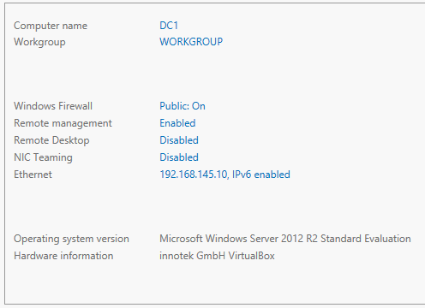

We next go to the top right corner of Server Manager and click on Manage and from the context menu, select, Add Roles and Features

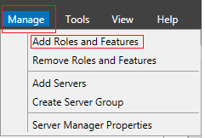

On the before you begin page, check the box to skip this page by default, and then click Next.

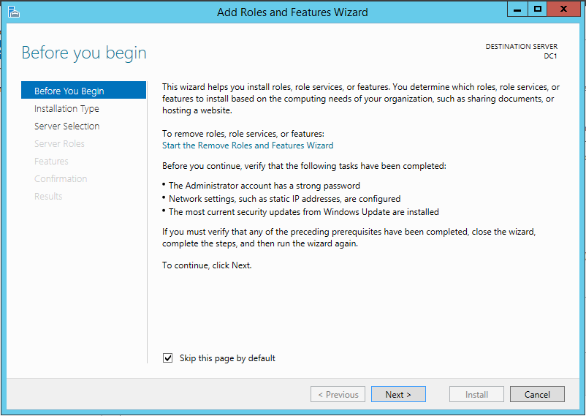

On the Installation Type page, accept the default and click next.

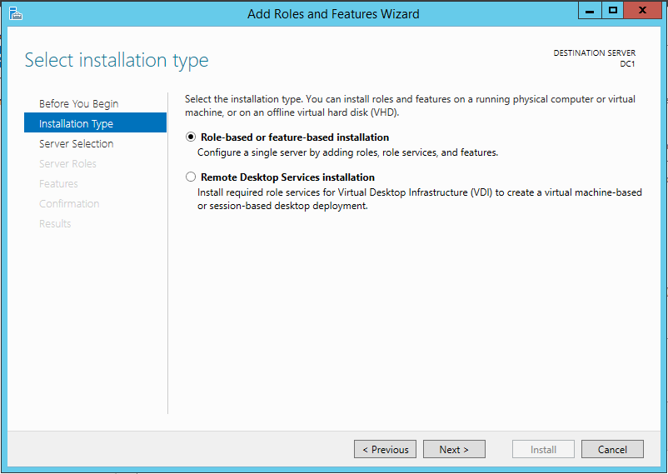

On the Server Selection, page, ensure the correct server has been selected. We only have one server, but in a production environment, any server added to your Server Manager console would be present. Click next.

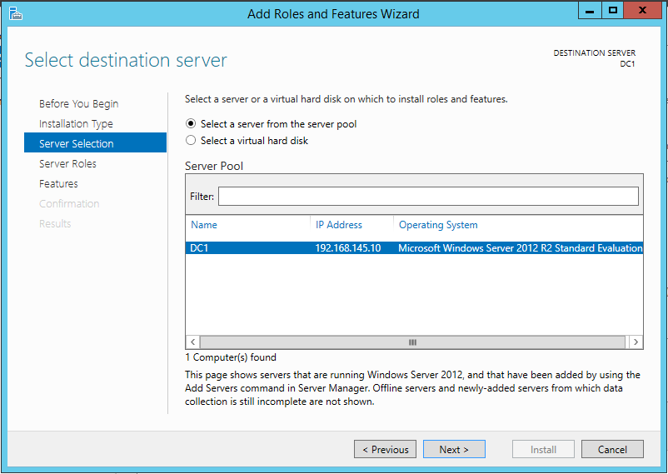

From the Server Roles page, select, Active Directory Domain Services, DHCP and Web Server (IIS). Each of these roles will have features that will need to be installed with them so click the, **Install features** option when they appear.

DNS will be automatically installed when we promote the server to a domain controller in part 2 of this lab. Click next.

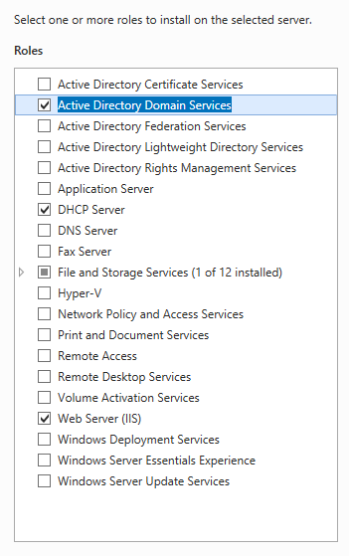

On the Web Server Role page, click next. On the Role Services page, click next. The next two pages are just informational. Continue to click next until you come to the confirmation page. This is your last chance to go back and make any changes if needed. Click the install button.

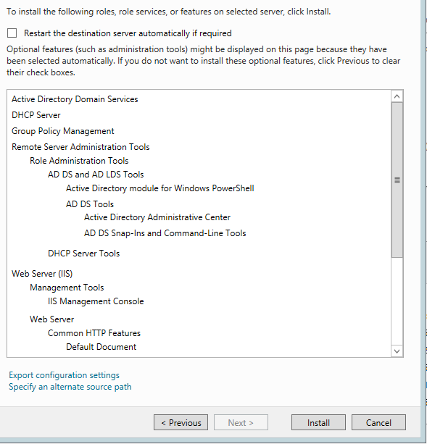

Allow the installation to complete. Close the Add Roles and Features Wizard and return to Server Manager.

You are now ready for part II of the lab, promoting this server to a domain controller.

**Part II: Promoting Server 2012 r2 to a Domain Controller**

Once the Active Directory Domain Services role has been installed, we can promote our server to a Domain Controller by following the below steps. In this lab, we will look at how to promote a Windows 2012 r2 Server to be a domain controller.

When we open to Server Manager, there is a notification message waiting for us. There are two notifications. Click on the first notification link to Complete the DHCP configuration. This opens the DHCP Post-Install configuration wizard. Accept the default user groups for managing DHCP Click on the commit button and the Next, click Close.

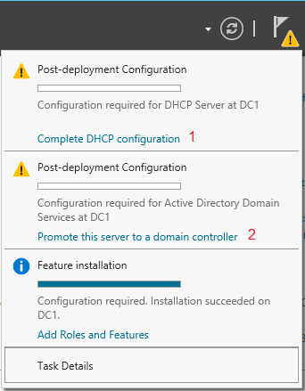

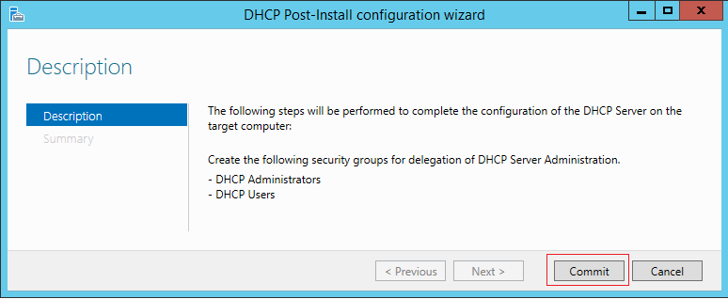

Return to notifications. From the notification box, click on the, “Promote this server to a domain controller” link. This will start the Active Directory Domain Service Configuration Wizard.

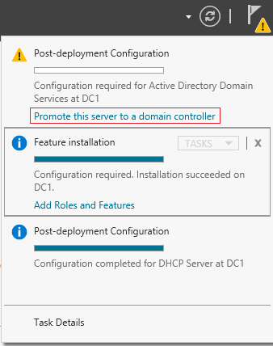

On the first screen of the wizard, select the radio button to **Add a new forest.** Enter the name for your new root domain. Refer to the previous lab on Preparing Your Network For Active Directory if needed.

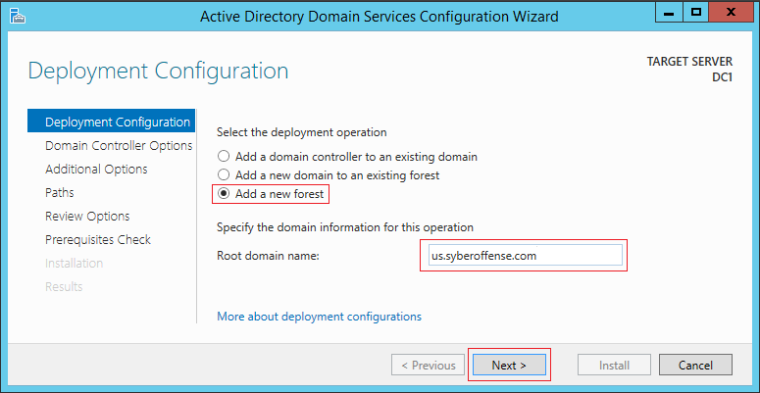

The wizard did not find DNS install, and we are given the option to install the DNS now.

**Since DNS is not present, the option to install DNS is provided. Leave the box checked as DNS is a requirement for Active Directory. If the DNS option were grayed out, DNS would have been found to be installed and running.**

Leave the function for Server 2012 R2 as is. If we had server 2008 running on the network, we could downgrade the function to accommodate the need for backward capability.

Type in your Directory Service Restore Password and click next.

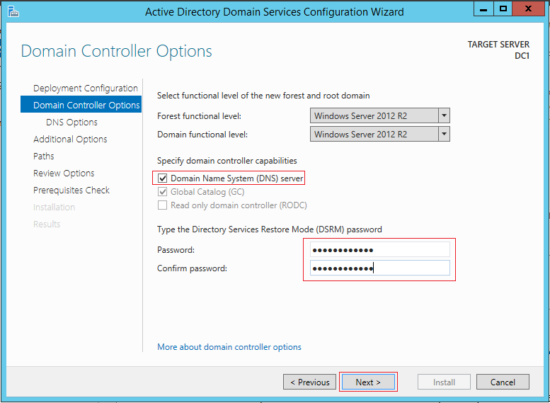

Ignore the following DNS warning and click next. We have no other DNS servers on the domain, so there is nothing to delegate with or to.



The wizard selects a **NetBIOS domain name**. The NetBIOS name is for legacy systems such as Windows 95, 98, NT 4.0. Some software will use NetBIOS names to find their way around the network. NetBIOS names are restricted to 15 characters. If you don’t like the NetBIOS name chosen by the wizard, you are free to change it. Click on **Next**.

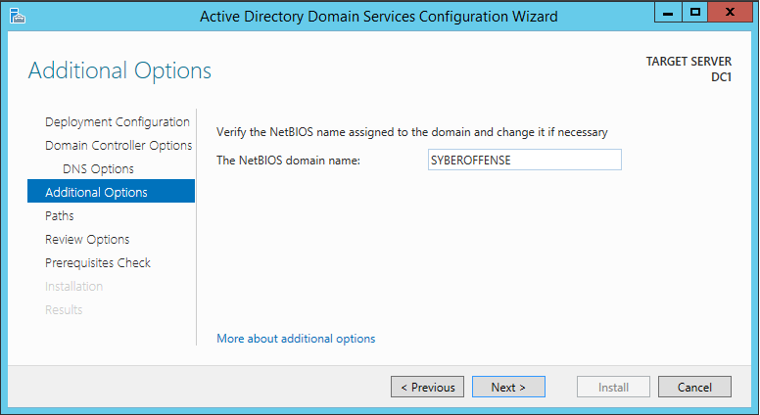

Accept the default paths for the database, log files, and SYSVOL folders.

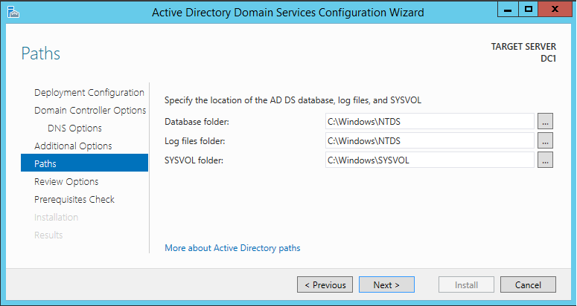

Review the summary and click **Next** to promote the server to Domain Controller.

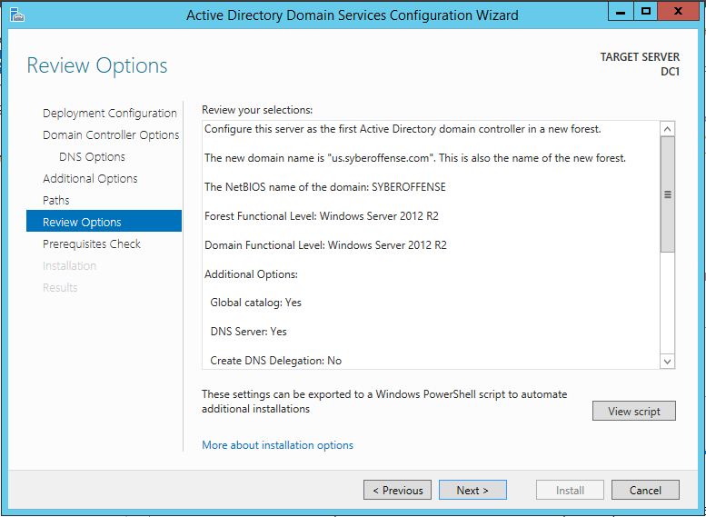

Once prerequisites have passed successfully, click on **Install**. The yellow notifications can be ignored as these are the default warnings about backward compatibility with legacy operating systems. These default notifications have been seen going back as far as Server 2003. The only check you need to concern yourself with is the final green check at the end.

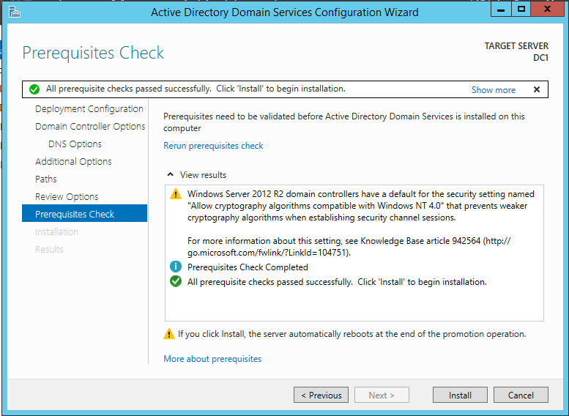

The system will restart once installation is completed. Be patient! When the machine restarts and comes back up, you will have an Active Directory Domain controller.

Once the machine comes back up, and Server Manager has loaded and refreshed, under the Dashboard you can see the roles installed.

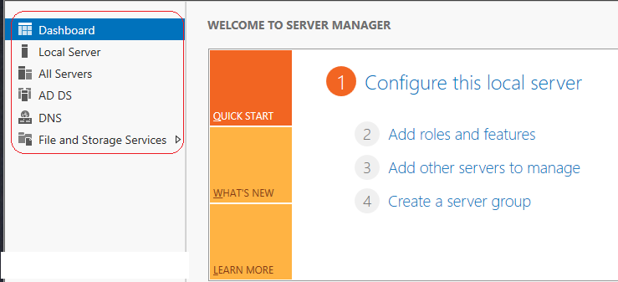

**Summary –**

In this lab, you learned how to properly promote a server to a domain controller using **Server Manager**. In part II of the Server 2012 course series, students are given the opportunity to use PowerShell to promote a Windows server to a domain controller.